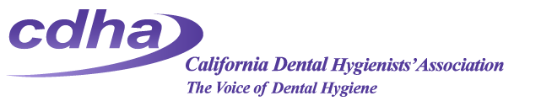

The California Dental Hygienists’ Association invites you to JOIN NOW!

At its 2016 House of Delegates held June 3-5 in Fresno, California, the Delegates ratified the Board of Trustees’ action to end the existing charter with the American Dental Hygienists’ Association (ADHA). Although we valued our relationship with ADHA, it was time and in the best interests of CDHA and all California hygienists to break away from that long-standing structure.

What does that mean?

CDHA is a stand-alone organization and your dues payment will provide for membership in CDHA and your local component. All membership dues will go towards the advancement and support of the California dental hygienist profession.
Any membership payment made to ADHA after June 5, 2016 will not be credited towards your CDHA or local component membership.

If you are a current member of ADHA and CDHA, your membership with CDHA is valid through your current membership expiration date and then you will need to join through CDHA Central Office for your state and local component membership.

What is the cost of membership?

CDHA dues are $210/year and component dues are $20-$30/year depending on the component. A membership application form is attached.

If you have renewed with ADHA after May 1, 2016, please contact the CDHA Central Office to confirm your membership status.

Membership FAQs

I want to remain a member of CDHA and ADHA. How do I do that?
To join with CDHA and your local component, you must join through CDHA Central Office. Please contact ADHA for information on retaining membership at the National level.

How do I join with CDHA and my component?
You may complete the attached membership form or call Central Office at 916-993-9102. There will be an online submission form very soon!

My renewal date with ADHA before the HOD vote was December 31, 2016. Am I still a CDHA member?
Yes, if you renewed through ADHA before May 1, 2016, your membership payment to CDHA and your component was received and you do not need to send membership forms to CDHA until that date.

Please contact Central Office or your Component Trustee to learn how the new CDHA membership structure will BENEFIT YOU!

California Dental Hygienists’ Association
1900 Point West Way, Suite 222
Sacramento, CA 95815
(916) 993-9102
memberservices@cdha.org

